Wrangell Chamber of Commerce, 907-874-3901
www.wrangellchamber.org

RULES & REGULATIONS

*Please note: For the 2015 fair, all entries must strictly adhere to the entry rules that pertain to each Department. ALL entries must have been made in the last year, unless otherwise specified in the Department Rules.

Entries not meeting all the requirements of the Department Rules WILL NOT BE ACCEPTED.

Please thoroughly read your Department Rules

- Entries are open to all.
- Exhibitor must be the bonafide maker or grower of the article. Items that are not the work of the exhibitor may be entered for display only.
- With the exception of live plants, no entry shall have been previously entered in the Wrangell Fair for judging. Exhibits must have been completed within the past year unless otherwise specified.
- Every possible precaution to protect the exhibits and property while they are being exhibited will be taken, but it is understood that the Wrangell Chamber and Nolan Center shall in no way be held responsible for loss, damage or injury of any kind from any source whatsoever.
- Any additional rules pertaining to a specific Department will be defined within that Department description.
- The right is reserved to refuse or accept conditionally any entry offered.
- The Wrangell Chamber of Commerce reserves the final right to interpret these rules and regulations and to settle all questions connected with or incident to the Wrangell Fair which are not covered herein.

ENTRY PROCEDURE

Exhibitors must have completed entry forms (Just Entry Forms, not Exhibits) to the Chamber no later than: Friday, June 26th, 2015.

Exhibit Drop Off: June 29th, 12-4pm Nolan Center

IT'S THE RESPONSIBILITYOF THE EXHIBITOR TO FILL OUT AN EXHIBIT TAG FOR EACH ITEM ENTERED.
Be sure to include your correct mailing address, phone number and email address. Exhibits which have been improperly entered in a Class, may at the discretion of the Chamber Representative be transferred to the proper Class before judging.

Please use the charts on the following page to consider your "DEPARTMENT"

The "CLASS" definitions are on the corresponding pages.
DIVISIONS
Within each department there are divisions based on age or level of expertise. The exhibitor must choose the applicable division.

JUNIOR DIVISION
Exhibitors age 16 & under

SENIOR DIVISION
Exhibitors age 17 & Up

PROFESSIONAL DIVISION
For exhibitors who have taught for a fee, or have sold more than $500 in merchandise in the exhibit department category entered in one calendar year.
DEPARTMENTS A-W
There are classes that fall under each department

AGRICULTURE
A Crops & Vegetables
B Flowers
HOME ARTS
F Baked Goods
G Beer & Wine
H Preserved Foods
I Crochet
J Knitting
M Quilting
N Sewing
FINE ARTS & CRAFTS
O Fine Arts
P Fine Crafts
Q Creative Writing
R Photography
S Woodworking
T Native Style Arts
U Pioneer Arts & Recycling
V Hobbies & Crafts
YOUTH
W School Projects

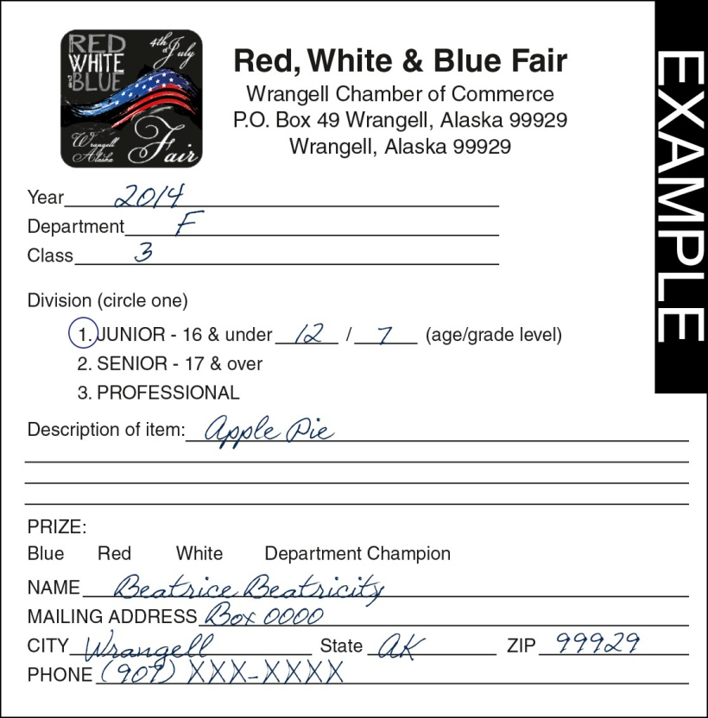

COMPLETING EXHIBIT TAGS
- Each exhibit must be accompanied by an Exhibit
Tag, which is available at the Chamber Office
- Circle Applicable Division
- Junior Entrants should include Age/Grade Level
- Fill out all personal information fully and correctly
- Attach to exhibit
EXAMPLE EXHIBIT TAG
EXAMPLE: Junior, Age 12, 7th Grade, Apple Pie

METHODS OF JUDGING - Judging results will be recorded on each exhibit tag
Danish System
Junior entries in all Departments and entries in the Creative Writing and Music are judged according to the Danish System. The Danish System of judging is based upon established standards of quality for each type of product. Each exhibit is judged according to how well it meets that standard rather than how it compares with other exhibits (as in the American System). Blue ribbons earn a score of 90-100, red ribbons 80-89, white 70-79.

The American System is used in all other departments. In the American System, entries in each class are judged in comparison to the other entries in the class. Entries are then awarded first place, second place and etc.
RIBBONS
Department Champion – Large Rosette
First Place – Blue Ribbon, Second Place – Red Ribbon, Third Place – White Ribbon

DEPARTMENTS
DEPARTMENT A - CROPS & VEGETABLES
Judging System: American
- All entries in this Department should be true to type and variety, medium in size, uniform, and of good quality. They must be clean, no dead foliage, free from insect or other injury, in edible condition. Root vegetables should have the tops trimmed to one inch. Whole plant classes have the roots removed, but may retain three wrapper leaves for effective display. Bunch classes should be tied with a rubber band, string or metal fastener.
Class 1 – Field & Greenhouse Grown Vegetables
Class 2 – Herbs (All herbs should be fresh and secured in sheaves approximately ½ inch in diameter)
Class 3 – Wild Berries (Half Pint per exhibit)

DEPARTMENT B – FLOWERS
Judging System: American
- All specimens must have appropriate self-foliage attached to the stem of the specimen unless otherwise noted.
- A tightly closed bud or one that has not sufficiently expanded to show the typical form and beauty of the coming bloom is not acceptable as a bloom.
- A spike is a specimen with short or long inflorescence, usually unbranched except in delphinium. Florets surround the main axis at close intervals with buds developing on the elongated tip, as in lupines, delphinium and gladiolus.
- A spray consists of one stem (not a branch), with or without a central flower or bud. Any erect spray with the lead bloom open will be acceptable. Nemesia, cosmos and godetia are spray types.
- Stalk designates a stiff stem, branching or not, with one or more flowers such as clarkia, annual larkspur and lily.
- Stem is the main axis of a plant.
- Bloom is used to designate an individual flower terminating a stem, such as exhibition type roses.
- Grooming: Flowers and plants should be groomed to remove dirt and spray residue, as well as dead foliage. Specimens may be groomed in any way which does not alter their typical features.
Class 1 – Wildflowers Class 2 – Flowers, cut Class 3 – Potted/Hanging Baskets Class 4 – Artistic

DEPARTMENT F - BAKED GOODS
Judging System: American - One whole loaf per Class
- Please consult the Entry Procedure for general entry rules.
- Special Instruction: All entries in this department must be home prepared by the exhibitor. Exhibitor should wrap their own exhibits in cellophane or plastic wrap. Please use disposable containers. A list of ingredients is required.
- All entries in this department become property of the Wrangell Fair unless otherwise noted on exhibit tag.
Class 1 – Yeast Breads Class 2 – Quick Breads Class 3 – Pies Class 4 – Cookies Class 5 - Cakes

DEPARTMENT G - BEER AND WINE
Judging System: American - Must submit 2 bottles per beer entry or 1 bottle per wine entry
- Special instructions: All entries in this exhibit should be in clean, appropriate bottles not larger than one quart labeled with class.
- Entries will not be returned unless specified on the entry tag.
- A list of ingredients is required with each entry.
- Entries should be true to class entered.
Class 1 – Beer Class 2 – Wine

DEPARTMENT H - PRESERVED FOODS
Judging System: American - Only one entry per Class
-Special instructions: All entries must have been prepared by the exhibitor within the past year. Due to an increased hazard of botulism, Junior and Senior division entries of PRESERVED MEATS and UNPICKLED vegetables will be judged by APPEARANCE only. Professional division entries should be approved for commercial sale, and may be tasted during judging.
- Dried preserved food exhibits may be submitted in plastic bags.
- Containers must be standard canning jars with 2-part lids, and labeled with identity of product, method, processing time and date of processing. Example: Smoked Salmon, 11# Pressure, 110 Minutes 8/11/92
-No label means disqualification. Incomplete or inaccurate labels will result in a reduced score.
- Bring one jar only. Processed jars must be sealed and have rings in place.
- Jellies, jams, butters, marmalades, preserves, etc. must be in standard 12 oz. or less jars. Seafood should be in one-pint or 1/2-pint standard jars, and all other products in one-quart or smaller standard jars.
-The use of paraffin is no longer approved by the USDA, so entries sealed with wax will be disqualified.
-Recipe or list of ingredients must be securely attached to entry.
- Cooperative Extension Service/USDA bulletins: Juneau: 465-8749, Sitka: 747-6065, Ketchikan: 225-3290.
Class 1 – Jams Class 2 – Pickles and Relish Class 3 – Fish Class 4 – Meats Class 5 – Vegetables

DEPARTMENT I - CROCHET ARTS
Judging System: American - Only two entries per Class
Broomstick, Hairpin Lace, Cro-Hooking, Afghan Stitch, Tatting, Hook & Punch, Etc.
- Special instruction: Entries should have been completed within the last year, have a new appearance and be clean.
- All entries must be properly finished, i.e. framed (ready to hang), stuffed, blocked, hemmed, Etc.
Class 1 – All Crotchets

DEPARTMENT J – KNITTING
Judging System: American - Only two entries per Class
- Special instructions: Entries should have been completed within the last year, have a new appearance and be clean.
- All entries must be properly finished, i.e. stuffed, blocked, hemmed, etc. Please list fiber content on entry tag.
- A brief statement covering the function, type of design and materials used would be helpful.
Class 1 – All Knitting

DEPARTMENT M – QUILTING
Judging System: American - Only one item per Class
- Special instructions: A sleeve or tab should be sewn on the top edge of quilts for hanging display. To insure cleanliness and safety of entries en route to and from fair, all entries should be enclosed in a sealed plastic bag and clearly marked with owner's name and address. These bags will be reused to return entries. All entries must be made within the last year, reasonably clean and properly finished. IN CONSIDERATION OF JUDGES WITH ALLERGIES, PLEASE remove all cat and dog hair.
- All items for sale must be clearly marked.
Class 1 – Large Quilts Class 2 – Wall Hangings

DEPARTMENT N – SEWING
Judging System: American - One entry per Class
-All entries should be CLEAN and have new appearance (not obviously worn)
-Entries will be judged on construction skills, appropriateness of techniques and materials used. Ornamentation will not be judged as it adds or detracts from the finished work.
Class 1 – Sewing

DEPARTMENT O – 2-DIMENSIONAL FINE ARTS
Judging System: American
- Special instructions: All entries must have been done within the past two years by the exhibitor, be dated and signed and have not been exhibited in a previous year at the Wrangell Fair.
- All entries must be labeled on the back showing name, mailing address, medium, title or description of the work. If there is a name on the front of the work, it should be covered by the exhibitor.
- All work must be original in concept. There must be no copies of paintings or professional photographs, no work from kits, and no copies of any published pictures.
- All entries must be matted and, wired for hanging, or covered with a clear protective sleeve.
Exhibitors may enter a maximum of three compositions in all classes.
Class 1 – Oils Class 2 – Acrylics Class 3 – Watercolors Class 3 – Drawing

DEPARTMENT P – 3-DIMENSIONAL FINE ARTS
Judging System: American
-Please consult the Entry Procedure for general entry rules.
-All entries must be labeled on the back showing name, mailing address, medium, title or description of the work. If there is a name on the front of the work, it should be covered by the exhibitor.
-All entries must have been done within the past two years, be dated and signed, and have not been exhibited previously at the Fair.
-All work must be original in concept.
-All 3-D free-standing entries must be stable.
Class 1 – Clay Class 2 – Carving Class 3 - Glass Class 4 – Metal Work Class 5 – Mixed Media

DEPTARTMENT Q - CREATIVE WRITING
Judging System: American
All entries will receive a ribbon.
- Please consult the Entry Procedure for general entry rules.
- Special instructions: All entries must have been done within the past two years by the exhibitor. The work must be original in concept – NO COPIES – The creative writing must never have been commercially published nor judged professionally before entry in the Wrangell Fair.
- Creative Writing entries must be typed DOUBLE SPACED on 8½”x11" paper on one side of the paper only. Illustrations should not overwhelm the written word. The exhibitor’s name and address MUST BE ON THE BACK OF EACH PAGE. Entry will be disqualified if name is showing on the front of any page.
- Note: It is not necessary to double-space poems if single space is part of the design.
Class 1 – Story Class 2 - Poems

DEPARTMENT R – PHOTOGRAPHY
Judging System: American (Danish for youth entries)
-Two (2) entries are allowed per class.
-Photographs should have been taken within two years and not entered previously. Please note that judging is based solely on the photograph, not the mounting or matting.
-Exhibitor name, address, and phone number must be noted on the back of each photograph.
-No lewd or illicit images will be judged or displayed, as determined by the Fair staff.
IMPORTANT – PLEASE READ!
PHOTO MOUNTING:
Images must be securely mounted on a board cut to the following dimensions:
-Finished sizes of entries should be either 8”x10” or 11”x14”.
-Please, no other sizes.
-Sizes pertain to the board and the finished mounted print, not the photo itself. Prints may be of any size that fits on the acceptable sized board. Any matting must also fall within the maximum sizes listed above.
-Completed mounts must be in a fitted clear sleeve or properly shrink-wrapped. No framed or glass mounted images.
-Do not apply hangers to the back of entries. The Fair will provide Velcro tabs to be affixed to all entries.
-To ensure anonymous judging, please do not place any identifying text or logo on the front of the entry. Label the back of each entry with name, mailing address, and phone number.
Class 1 – Scenic Class 2 - People Class 3 – Animals/Birds Class 4 – Life in Alaska Class 5 – Digitally Manipulated

DEPARTMENT S – WOODWORKING
Judging System: American- One entry per Class
- If made from a kit, please note on tag.
- Exhibitor should note under description on exhibit tag if item was assembled from a kit.
- Carvings should be entered in Fine Crafts.
Class 1 – Furniture Class 2 – Mixed Media

DEPARTMENT T - NATIVE-STYLE ARTS
Using materials, skills and motifs native to Alaska (Not limited to entries by Alaska Natives or Native Americans)
Judging System: American- One entry per Class
Class 1 – Leather & Fur Class 2 – Weaving Class 3 – Beadwork Class 4 - Metal

DEPARTMENT U - PIONEER ARTS and RECYCLING Judging System: American - One entry per Class
- Special instructions: Entries should have been completed within the last year, have a new appearance and be clean.
- All entries must be properly finished and ready for display.
Class 1 – Recycling Class 2 – Bones and Horns

DEPARTMENT V - HOBBIES & CRAFTS
Judging System: American - One entry per Class
Class 1 - Nature Craft (Rock, Seashells, Driftwood, Feathers, Pine-cones) Class 2 – Ceramics Class 3 - Flowers
Class 4 - Paper-craft

DEPARTMENT W - SCHOOL AND YOUTH ORGANIZATIONS PROJECTS
Special instructions: Judging will be by the Danish system
-Work must be done during the prior school year.
-Entries are to be primarily the work of the exhibitor.
-Age and grade of the exhibitor must be noted on the exhibit tag.

DEPARTMENT P – WEARABLE ARTS
Judging System: American
-Special instructions: All entries must have been done within the past two years by the exhibitor and have not been exhibited in a previous year at the Wrangell Fair.
- All work must be original in concept. There must be no work from kits.
-Wearable Art refers to original handmade apparel or jewelry, designed and created as fine or expressive art.
-The use of non-traditional materials for clothing will have emphasis on upcycling, and/or recycling.
-The wearable art entry must be an original concept designed and created by the entrant(s). The entry cannot use fire, explosives, live animals, or weaponry.
-A brief statement describing the function, type of design and materials used should be included.
-Judging will be done based on the entry’s originality, artistic merit and vision, creativity, use of materials, and design.
Class 1 – Woman’s Clothing Class 2 – Men’s Clothing Class 3 – Children’s Clothing

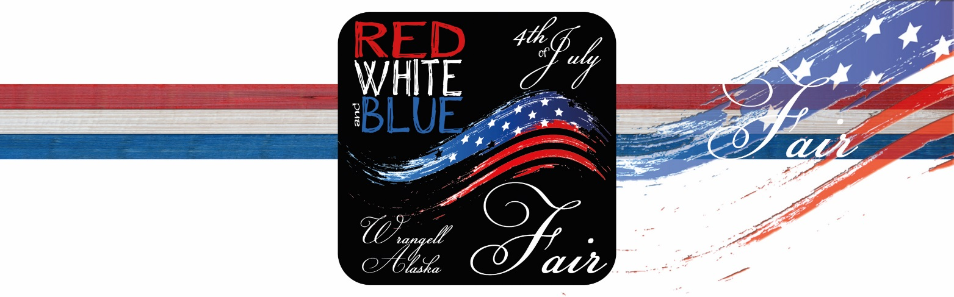
- Each exhibitor may enter four (4) individual exhibits (1 per Class) in his/her age group. This includes individual projects entered in School, Scouts and Youth Organizatio
EXHIBITOR ENTRY FORM

Your Name _________________________________________________________________________

Mailing Address ____________________________ City ______________State ______ Zip _________

Telephone _____________________________ Cell _________________________________________

Please list your exhibit(s):

DEPT.  (A-W) | CLASS | DIVISION  Junior 16 and under,  Senior 17 and up, or Professional |  | DESCRIPTION
_____ | __________ |  | ______________________ | _____________________________________________
_____ | __________ |  | ______________________ | _____________________________________________
_____ | __________ |  | ______________________ | _____________________________________________
_____ | __________ |  | ______________________ | _____________________________________________
_____ | __________ |  | ______________________ | _____________________________________________

*If you have additional exhibits please use back of this form. Thank You.

Would you like us to send your exhibit to the Southeast Alaska State Fair in Haines? Y / N

